DECEMBER 2020 Market Report

.

During one-month period to 30th November, major equity markets, as measured by the aggregate FTSE All – World Index rose strongly reversing the weak October performance, largely on favourable developments regarding possible Covid-19 vaccines, and initial relief at the US election result. A simultaneous sector/style switch also led to outperformance by some of the previously “neglected cyclical and value orientated” stocks, sectors and indices e.g FTSE100. The VIX index fell sharply to 21.77, as more risk taking became prevalent. Government stocks prices fell while many other credit prices rose leading to a sharp contraction in spreads. Currencies featured general US dollar weakness, while the pound received a Brexit (nearly there!) related fillip. The Chinese Renminbi continued to rise, now up over 5% against the dollar since the beginning of the year. Commodities were generally firm.

In terms of global economic data, there were no real changes to near term aggregate projections, the IMF and OECD currently looking for about a 4.4% decline this year to be followed by a tentative 5.5% rebound in 2021.However,the vaccine news, while still awaiting regulation clarification, scale production,distribution,administration etc has brought forward and increased some estimates for longer term economic recovery. The fact that certain countries e.g USA are still experiencing an acceleration in positive coronavirus cases and that other countries are proposing various on/off lockdowns point to continued country/sector variation, and related fiscal and monetary policy actions.

At the end of August Jackson Hole monetary policy symposium the Fed adopted a new monetary policy strategy that will be more tolerant of temporary rises in inflation, cementing expectations that the US central bank will keep interest rates at ultra-low levels for years. At this time of writing, recent economic data (retail sales, unemployment) point to a softening after the strong third quarter bounce and the deteriorating Covid-19 situation, which may prompt stricter lockdowns on a state by state ,do not auger well for fourth quarter growth. To add to this uncertainty, there is still no agreement between the political parties as to the size and timing of a stimulus package, and the final make-up of the House/Senate will not be known for some weeks. The appointment of former Fed chairperson, Janet Yellen as Treasury Secretary was generally seen as a positive factor.

At the November ECB Council meeting interest rates were left unchanged as were the amounts of the various asset repurchase programmes and the operation of the refinancing programme. However, Council members are increasingly divided about further economic stimulus against a worsening Covid-19 background and weaker inflation, and Christine Lagarde hinted strongly that more stimulative measures could be employed in December (meeting 10th). Very recent Sentiment surveys e.g the November flash PMI figures suggest,
as in the UK case, a weak fourth quarter, and many lockdowns, of varying intensity are currently in place. Not surprisingly the service sector is suffering more than manufacturing, the German manufacturing PMI, for example, rising over the same period. The ECB Budget process seems to be reaching a conclusion, regarding the Budget and Recovery Fund, despite Hungarian and Polish law and order/aid issues!

Asia excluding Japan, led by China(across all sectors and property), is generally in better shape than other major regions( virus response, economic mix).Korea for example expects a 2020 GDP decline of just 1.5%,while positive growth is expected in Vietnam. Japan, with a relatively muted Covid-19 experience, is expected to experience a relatively smooth transition under the new PM,Yoshihide Suga and experienced 5% growth in the third quarter, higher than expectations.

China specifically has been reporting relatively strong economic data e.g provisional third quarter GDP and is likely to post positive GDP growth this year of around 2%-4%.PMI just released yesterday shows stronger than expected growth. A recent government bond issue, oversubscribed, despite the tiny yield, is an example of hunger for certain Chinese assets, although the last minute pulling of the Ant equity issue and certain corporate bond defaults ,provided a reminder of some of the risks.

Within the UK, provisional GDP figures, showed growth of 15.5% during the third quarter( after a second quarter 20% decline).More recent data showed a slowdown in October and, of course, further weakness in November ,a period of lockdown for much of the country. A tiered approach and selective loosening over the Christmas period will probably not be enough to avert a fourth quarter decline overall. However, although early days until full effective roll out of recently announced vaccines, economic estimates and corporate confidence are starting to rise from spring 2021 onwards.Nonetheless, Brexit related issues, rising bankruptcies, short term unemployment, greater poverty, loan repayments and the spectre of higher taxes must all be considered.

The Chancellor’s Autumn statement, full of records of an unwelcome variety, highlighted the weak economic growth (-11.3% 2020, followed by 5.5% then 6.6%), budget deficit 19% of GDP this financial year and an expectation of 2.6 million unemployed. A no-deal Brexit would worsen these figures. Post Covid-19, hard decisions on debt, spending and taxes will have to be made. As a cheeky aside, I note that in the small print of the Chancellor’s statement, I saw that the largest increase in Government departmental Budgets is reserved for HMRC! Higher taxes/more taxes/tax evasion clampdown, Brexit paperwork...take your pick!

Analyst’s estimates expect average global corporate earnings to decline around 17%in 2020 with a tentative rebound of over 25% next year Source (Morgan Stanley). There is exceptionally large country to country variation. Europe, including UK, is expected to underperform the US in 2020 while outperform in 2021, while Japan is one of the zones experiencing more economic and corporate resilience. This is also true in China, but also Korea and Taiwan where the combination of better COVID experience and export mix (technology, medical) is cushioning the economic blow. Reflecting the above and noting index sectoral breakdowns, dividends seem likely to fall furthest and recover most strongly in Europe.

Although currently further from investor worries, growing concerns regarding global trade tensions (many), government debt (over 100% Debt/GDP), USA/China/Australia/Hong Kong relations, BREXIT, and Senate make up are not far away. It will be increasingly important to watch inflation trends, as any “shock” necessitating greater than forecast bond yields could have serious repercussions for many asset classes.
More intangible in nature, the pandemic also seems certain to amplify global inequalities (regional, medical, employment, poverty, demographic) which could manifest in growing social unrest.

Equities
Global Equities showed a large gain, in aggregate over November ,2020, one of the largest monthly gains on record. The FTSE ALL World Index registered a gain of over 12% over the month and is now up over 10% since the year end, in dollar terms. The UK broad and narrow market indices rose by approximately 12.5% during November but have still declined around 16% since the beginning of the year. European and Japanese equities led the monthly gain, partly due to the more cyclical/value index breakdowns while the NASDAQ,Asia-ex Japan and emerging markets lagged. The VIX index, ending the month at 21.77, showed a monthly fall of 43.64%.

UK Sectors
Huge variation was shown between sectors during the month, the gap between the best and worst performing sectors being over 31%%. Year to date, only one sector (mining) is in positive territory, the worst (oil and gas) still down 51%. The “average” All-UK unit trust is now down about 10% year to date with smaller companies outperforming significantly and income companies underperforming (-13.8%).However, over the last month the UK income sector was actually the leading IA unit trust sector, as large buying interest returned to oils,financials,telco’s and financials.

1 YEAR FTSE to November 27th
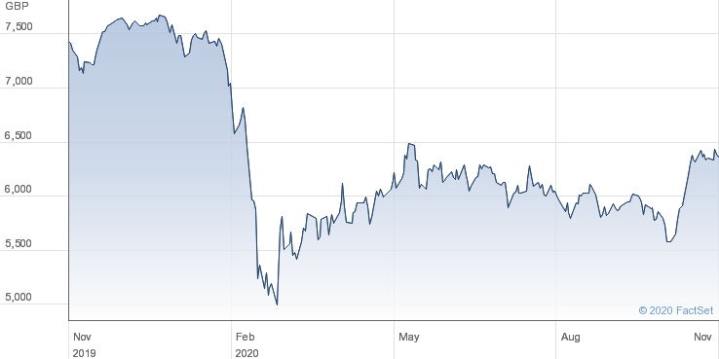

Fixed Interest
Gilt prices fell (Yields rose) 0.84% over the month, the 10-year yield now at 30 basis points (0.30%). Other ten-year government yields also rose closing the month at US, 0.85%, Japan,0.03%, and Germany, -0.57% .However, other credit mostly rose in price terms, whether US junk, emerging markets or mid quality UK corporates. This divergence suggests a continuing search for yield but avoidance of government debt, a stance, within reason, with which I can concur, but great care is warranted in instrument selection. The well anticipated future change in UK price indexation will not be helpful for some defined benefit pensioners or holders of “Linkers” …but railway season ticket holders and student loans will benefit, relatively! Check my recommendations in preference shares (note recent FCA/Aviva “apology”), corporate bonds, floating rate bonds, speculative high yield etc. A list of my top thirty income ideas from over 10 different asset classes is also available to subscribers.

Foreign Exchange
The major currency development during the month was the continued weakness in the US Dollar on a trade weighted basis, moves against some of the emerging market being particularly large. Sterling moved higher against major trading partners on the feeling that the Brexit negotiations were edging towards a “skinny” deal(yet to be confirmed at the time of writing).The Chinese renminbi continued to strengthen and is on course to record the largest six month move against the dollar on record. Interestingly, in sterling adjusted terms Japan has now overtaken the S&P as one of the leading equity markets year to date with a gain of 16%.

Commodities
Apart from gold, most major commodities rose, in price terms, during the month. Oil, copper, platinum, iron ore and coal showed double-figure gains. Gold traders reported weak ETF flows, to add to the generally softer Indian, Chinese and retail jewellery conditions reported earlier in the year. Maybe the other side of the trade just mentioned, but Bitcoin,reached a new recent high.

Looking Forward
Since my last report two major events, have reduced somewhat investor uncertainty going forward, and, while further detail/clarification is required on both the US Election and Covid-19 vaccines ,and other possible headwinds linger e.g Brexit, there is growing optimism for the path of economies. This changing mood has and will continue to affect sentiment across all asset classes in varying ways.

Following the format of last month, I make the following observations.

Observations/Thoughts

- SECTORS-The dramatic change in equity confidence, from early November, largely as a result of the Biden election victory and vaccine announcements prompted large sector/style changes with new focus on value, cyclicals expected to benefit from sharper economic growth. Conversely, a mixture of more defensive shares and technology names suffered relative weakness, and in many cases, actual price falls.
- As well as giving the FTSE 100 overall a relative boost, compared with the S&P due to sector breakdown, there was considerable sector rotation, often featuring sharp recoveries in previously neglected corners of the market. Expectations of higher demand and more controlled supply propelled the oil price higher and this fed through to oil equities,where more favourable balance sheet development and and dividend statements are helping this previously unloved sector bounce sharply. Note that some energy related corporate bonds have lagged the oil price recovery and look interesting. Mining stocks remain of interest with a growing number of underlying commodities responding to global growth impulses e.g copper while precious metals (excl gold) are still seeing interest. Certain Utilities are worth revisiting for maintained, or even increased, dividend payments, stable business and growing ESG credentials, although regulation/government interference should always be considered. The Telecom sector is starting to be the subject of more global corporate activity, and both major UK names represent value plays now. Technology holdings should be maintained but be aware of some stretched valuations (priced to perfection?), tax issues, as well as non-financial developments. Much of the Banking sector specific i.e. ultra-low interest rates, dividend deferrals, debt provisioning and stock specific( e.g HSBC news) now seems priced in, with many bank names trading well below book value, although domestic banks e.g Lloyds, will remain strongly associated with UK COVID developments. In many cases bank preference shares offer higher yields and better capital security now, although very recently HSBC,Santander and Standard Chartered have also hinted at restoring ordinary share dividends-a controversial topic!The Insurance sector currently offers a number of higher yielding value plays Clearly a very selective approach is needed in the areas of Retail, Hospitality and Travel. The likes of IAG,Whitbread and WH Smith have all completed large rights issues, which could certainly buy time over an uncertain period.Finally,having being negative on the general sector for a considerable length of time, I am turning more neutral on the quoted Property sector, both direct equities and investment trusts. Recent results have brought out the absolute lack of homogeneity within the sector.

- Looking at my three” home-made” stock baskets, balanced, high risk COVID-19 and low risk COVID-19 plays, there have been significant differences in share price performance, over the approximately eight months since the sharp market crash. I have also included an analysis of moves from 6th November, taking in the Biden election victory and the announcements of significant Covid-19 vaccine tests. AS the benchmark the FTSE,S&P and NASDAQ have risen approximately 6%,3%and 2%respectively between close 6th November and close November 30th.Over the same period, many of the “higher risk” usual suspects,IAG,Carnival,Easyjet,Cineworld and Gym Group have risen by over 50%,though still well down on 2019 high prices.However,mainstream stocks in the area of oil and gas,banks,insurance and property have also shown well above average gains on the expectation of rising economic growth late 2021 (and higher rates/lower defaults/dividends in the case of the banks).Conversely drug companies (yes, drug companies),homeworking plays,Peleton,Zoom etc have not only underperformed but actually declined in price terms!

- The last month has shown the importance of maintaining a balanced portfolio. Many companies in the value/cyclical area seem likely to recover further, while great selectivity will be required chasing the Covid-19 risk stocks. Some of these names could recover quite strongly but risks of bankruptcy, dilution, government interference/control should be considered.Conversely,previous” winners” have to be assessed both on their relative valuation, as well as relative earnings growth in a post pandemic world.

- Emerging Markets-Very difficult to adopt a “blanket” approach to the region (see graph below) with so many different COVID, commodity, debt,geo-political variables. Much of Latin America is experiencing an acceleration in COVID cases, as is India, while closer to home Turkey has been facing a volatile geo-political, interest rate and currency situation However, I continue to have a relatively favourable view on Vietnam (VOF +15% YTD), where the macro factors (COVID success, economic GROWTH!), stable FX,inward investment are positive features. Other Asian markets are also worth a look e.g South Korea. Russia, both bonds and equities, may appeal to value, income-oriented investors and enjoys a relatively favourable current/fiscal balance situation, although political developments can unsettle e.g mining sector tax. The active versus passive debate in 2021, will take extra significance as country selection consideration, China versus rest, and appropriate tech weighting will be important considerations.
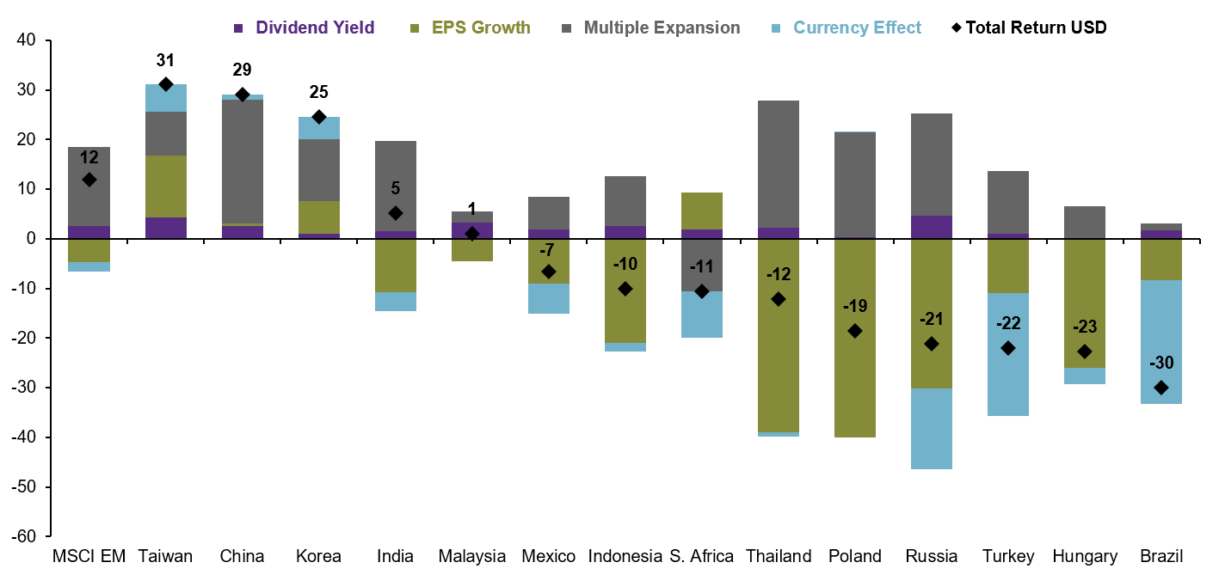
EMERGING MARKETS-Return Breakdown

Source:JP Morgan

- Not on near term investor (or government!) worry lists but be aware of the huge government DEBT problem building. Latest figures show aggregate global debt in excess of GDP at the global level and the mantra of extremely low servicing costs, is just that! Apart from short term haven buying, I expect conventional government FIXED INTEREST to suffer in the medium term, but other fixed interest options are available. Bond price weakness in November was apparent with each positive vaccine development

- FX- The pound may be vulnerable over coming months on a mixture of COVID developments, relatively weak economic data, Bank of England uncertainty, political wrangling and ongoing Brexit discussion. The Euro may be a beneficiary or Yen for haven, lower correlation characteristics or selective emerging market currencies for a higher risk approach. China and or Switzerland may resort to currency weakening action/rhetoric. Note the currency effect on the emerging market histogram above (the light blue bit!). Russia, Turkey and Brazil could surpass some of the Asian markets next year in currency adjusted total return terms.

- COMMODITIES- Gold appears to have broken down through the sideways trend that has been in place since August. Fundamental reasons are not hard to find and flows suggest that ETF selling has now combined with lacklustre Indian and Chines and jewellery demand. Bank actions. While longer term inflationary reasons and diversification benefits may apply the prospects for more cyclical plays may be more interesting now. This would explain some of the performance of some of the precious/industrial plays,silver,platinum,palladium.Copper, which has now rallied about over 60% since its March low, has benefitted from Chinese demand, “green” stimulus issues and some Covid-19 related supply issues and iron ore/coal are benefitting from a steel(especially in Asia) revival. In a UK context it might be worth remembering that planting and harvesting will be disrupted by both weather and labour shortages, which could potentially lead to pockets of food inflation.

- ESG Considerations-I have been reviewing several ESG (Environmental, Social and Governance) issues recently, both from personal interest, client curiosity and cognizant of the huge amounts of resource (both human and financial) being diverted to the sector. While applauding the longer term merits of such a move, I would advise extra layers of due diligence regarding “greenwashing”, choice of benchmarks, and shorter term considerations of values versus wallet (increasing stretch between tech and oil being a good example)-be careful what you wish for! November proved to be a classic example of above!

- COMMERCIAL PROPERTY…A quieter month for company figures and statements.However,the most recent MSCI/IPD UK Property Index for the ten months to end October showed an overall year to date return of -2.6% (-7.0% from capital and +4.6% from income) compared with +2.1% total return for the whole of 2019.The only sector to show positive capital change was in the area of SE industrial, while retail properties were down by nearly 16%. Continued due diligence is currently required in this sector both by asset type (direct equity, investment trust, or unit trust). On the more positive side there is growing evidence of corporate activity as predators, especially private equity or long term overseas institutional players see value. Many large property funds are re-opening, and it will be interesting to see updated cash levels, property valuations and data on investor flows. My current view is that investors may wish to slowly move back to a more neutral situation for he sector with my preference for investment trusts rather than unit trusts. Finally, the government is FINALLY tightening up on local authorities buying investment properties (horse bolted, Croydon etc!)

Full asset allocation and stock selection ideas if needed for ISA/dealing accounts, pensions. Ideas for a ten stock FTSE portfolio, model pooled fund portfolios (cautious, balanced, adventurous, income now available online for DIY investors), 30 stock income lists, defensive list, hedging ideas, and a list of shorter-term low risk/ high risk ideas can also be purchased, as well as bespoke portfolio construction/restructuring and analysis of legacy portfolios.
Feel free to contact regarding any investment project.

Good luck with performance!

Ken Baksh Bsc,Fellow (UK Society of Investment Professionals)
kenbaksh@btopenworld.com
1st December,2020

Important Note: This article is not an investment recommendation and should not be relied upon when making investment decisions - investors should conduct their own comprehensive research. Please read the disclaimer.

Disclaimer: Opinions expressed herein by the author are not an investment recommendation and are not meant to be relied upon in investment decisions. The author is not acting in an investment, tax, legal or any other advisory capacity. This is not an investment research report. The author's opinions expressed herein address only select aspects of potential investment in securities of the companies mentioned and cannot be a substitute for comprehensive investment analysis. Any analysis presented herein is illustrative in nature, limited in scope, based on an incomplete set of information, and has limitations to its accuracy. The author recommends that potential and existing investors conduct thorough investment research of their own, including detailed review of the companies' regulatory filings, and consult a qualified investment advisor. The information upon which this material is based was obtained from sources believed to be reliable but has not been independently verified. Therefore, the author cannot guarantee its accuracy. Any opinions or estimates constitute the author's best judgment as of the date of publication and are subject to change without notice. The author explicitly disclaims any liability that may arise from the use of this material.

